# Assignment Description

1. What is a pointer and how it is initialized ? (1 point)
2. How is a pointer declared ? (1 point)
3. How is variable accessed through its pointer ? (1 point)
4. What is the relationship between an array name and a pointer in C/C++? (1 point)
5. What is pointer arithmetic ? How is it performed ? (1 point)
6. Explain 5 with a programming example - include the efficiency of the program in Big O notation. (25 points)

# 1 Readme Documentation

1. A pointer is a variable which holds an address in memory. It “points” to an address rather than holding the actual value of the data the address contains. It is initialized by setting it equal to the address of some data by using the address of (&) operator.
2. It is declared with dataType *variableName. The asterisk is what makes it a pointer.
3. Dereferencing the pointer by *pointer will give you the data contained in the address pointed to by the pointer.
4. An array is a contiguous block of memory, and so an array name contains the address of the first block. You can access values in the array through arrayName[index]. The index iterates to the next blocks of memory so that you can access all the values of the array.
5. Pointer arithmetic is similar to how I described an array in the previous question. You can access memory before and after your pointer by adding and subtracting to your pointer. This is typically done within arrays, you have to be careful otherwise because it can lead to undefined behavior. When you do pointer arithmetic, it automatically moves the pointer by the size of the content contained in each block of memory(in bytes), which can be found using sizeof(variable).
6. The following program is a program which iterates through an array and finds the largest value. It uses pointer arithmetic to iterate and its efficiency is O(n) because the number of steps to finish the algorithm scales linearly with the length of the array.

# 2 Flowchart Screen Shots

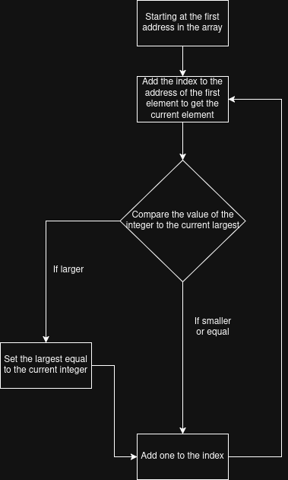

# 3 UML and Use Case Diagrams

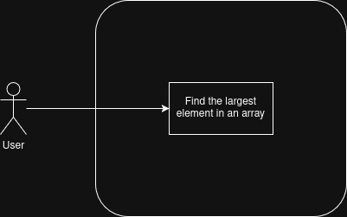

# 4 Source Code of All files (.h, .cpp)

#include <iostream>

/*

Name: Pointer Arithmetic Example

Author: Wesley Hixon

Date Last Updated: 10/30/25

Purpose: Demonstrate pointer arithmetic

*/

int main(){

int arrayCapacity = 10;

int arrayOfInt[arrayCapacity] = {1, 4, 12, 345, 312, 556, 123, 234, 222, 124};

int largest = 0;

std::cout << "Here is the array:" << std::endl;

for(int i = 0; i < arrayCapacity; i++){

// This is the pointer arithmetic

int current = *(arrayOfInt + i);

std::cout << current;

if(current > largest){

largest = current;

}

if(i < arrayCapacity - 1) std::cout << ", ";

}

std::cout << std::endl << "This is the largest element of the array: " << largest << std::endl;

return 0;

}

# 5 Three Use Case Screen Shots

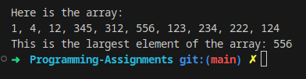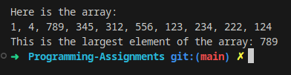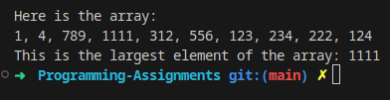

# (Optional) GitHub URL